**Design Patterns and how we can implement them**

***Creational Design Patterns***

* **Abstract Factory Method** -> how supplies and ammo are delivered to different base

camps (trucks, ship, aircrafts)

-> different types of ammo manufactured (guns, rifles, snipers, knives, grenades)

-> different types of supplies manufactured (food, clothing)

- **Prototype** -> to create soldiers

-> to create ammo

-> to create supplies

***Structural Design Patterns***

* **Composite**

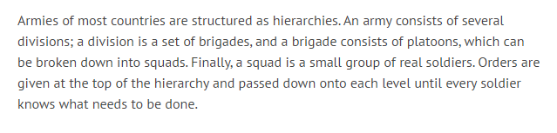

* **Decorator** -> different type of armour that soldiers wear (shield, combat helmet,

ballistic vest

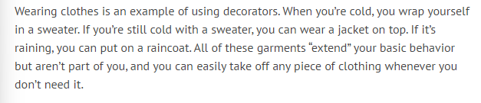

* **Singleton**

* **Facade** -> representing the managers of the Factories which manufacture the

ammo and supplies

***Behavioural Design Patterns***

* **Chain of Responsibility** -> passing on messages to family of soldiers who were

killed in action

-> passing on messages between allies

- **Command** -> writing down a “game plan” of how to go about winning the war so

that everybody knows their role

* **Iterator** -> to keep track of all the enlisted soldiers

-> keep track of all ammo and supplies manufactured

-> keep track of all soldiers that are wounded/killed/missing

* **Mediator** -> a central base camp in which all soldiers go back to/ communicate with regularly

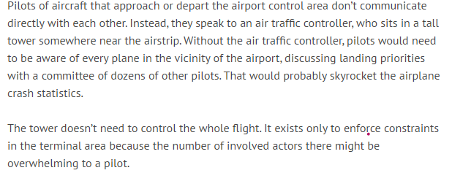

* **Observer** -> a newspaper or news update for civilians to keep track of

what is going on in the war

*

* **State** -> country’s flag’s state (home flag, white flag, alliance flag)  
  Armed forces
* **Strategy** -> different attack methods
* **Visitor** -> Distribution
  + 
  + Use with the abstract factory, whatever product the abstract factory creates gets sent to the visitor and it delivers it to different provinces
* -> different types of transportation to take injured soldiers back to base camp
* -> different types of transportation to take soldiers to place of attack
* -> different types of transportation to transport ammo and supplies from
* factory to base camps
* -> different ways of communication (walkie-talkies, letters, email)